CUSTOM BOOTCAMP
Big Data and Azure Fundamentals

Slowly Changing Dimension Case Study

CREATING A DEMO TABLE

CREATE TABLE EMPLOYEE (
EmployeeName VARCHAR(30),
EmployeeDOB DATE,
EmployeeGender VARCHAR(10),
EmployeeLocation VARCHAR(30),
EmployeeContactNo NUMBER(10)
);
INSERTING RECORDS
INSERT INTO Employee VALUES ('Ram Kumar', '01-01-1990', 'Male', 'Delhi', 7898528527);

INSERT INTO Employee VALUES ('Sunita', '02 Feb 1991', 'Female', 'Bangalore', 473639100);

INSERT INTO Employee VALUES ('Ajay', '01 Feb 1985', 'Male', 'Hyderabad', 438787821);

INSERT INTO Employee VALUES ('Naveen', '05 Feb 1991', 'Male', 'Chennai', 444567654);

CREATING TYPE-1 TABLE

CREATE TABLE D_Employee (
PK_Employee_Key INT,
E_Contact_Number Number(10),
E_Name VARCHAR(30),
E_DOB DATE,
E_Gender VARCHAR(10),
E_Location VARCHAR(30),
Created_Date Timestamp,
Updated_Date Timestamp
);

INSERT INTO D_Employee
VALUES (1, 7898528527, 'Ram Kumar', '01 Jan 1990', 'Male', 'Delhi', SYSDATE, NULL);
INSERT INTO D_Employee
VALUES (2, 473639100, 'Sunita', '02 Feb 1991', 'Female', 'Bangalore', SYSDATE, NULL);
INSERT INTO D_Employee
VALUES (3, 438787821, 'Ajay', '01 Feb 1985', 'Male', 'Hyderabad', SYSDATE, NULL);
INSERT INTO D_Employee
VALUES (4, 444567654, 'Naveen', '05 Feb 1991', 'Male', 'Chennai', SYSDATE, NULL);
SELECT * FROM D_Employee;
CREATING TYPE-2 TABLE

CREATE TABLE D_Employee (
PK_Employee_Key INT,
E_Contact_Number Number(10),
E_Name VARCHAR(30),
E_DOB DATE,
E_Gender VARCHAR(10),
E_Location VARCHAR(30),
Start_Date Timestamp,
End_Date Timestamp,
Version Number,
Flag VARCHAR(1)
);

INSERT INTO D_Employee
VALUES (1, 7898528527, 'Ram Kumar', '01 Jan 1990', 'Male', 'Delhi', SYSDATE, NULL, 1, 'Y');
INSERT INTO D_Employee
VALUES (2, 473639100, 'Sunita', '02 Feb 1991', 'Female', 'Bangalore', SYSDATE, NULL, 1, 'Y');

INSERT INTO D_Employee
VALUES (3, 438787821, 'Ajay', '01 Feb 1985', 'Male', 'Hyderabad', SYSDATE, NULL, 1, 'Y');

INSERT INTO D_Employee
VALUES (4, 444567654, 'Naveen', '05 Feb 1991', 'Male', 'Chennai', SYSDATE, NULL, 1, 'Y');

SELECT * FROM D_Employee;

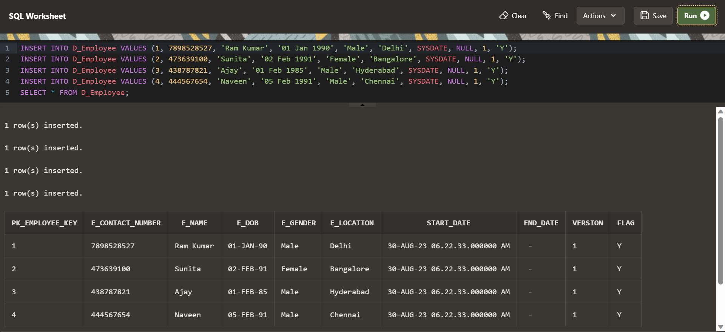

CREATING TYPE-3 TABLE

CREATE TABLE D_Employee (
PK_Employee_Key INT,
E_Contact_Number Number(10),
E_Name VARCHAR(30),
E_DOB DATE,
E_Gender VARCHAR(10),
E_Location VARCHAR(30),
Prev_E_Name VARCHAR(30),
Prev_E_DOB DATE,
Prev_E_Gender VARCHAR(10),
Prev_E_Location VARCHAR(30),
Created_Date Timestamp,
Updated_Date Timestamp
);

INSERT INTO D_Employee
VALUES (1, 7898528527, 'Ram Kumar', '01 Jan 1990', 'Male', 'Delhi', NULL, NULL, NULL, NULL, SYSDATE, NULL);

INSERT INTO D_Employee
VALUES (2, 473639100, 'Sunita', '02 Feb 1991', 'Female', 'Bangalore', NULL, NULL, NULL, NULL, SYSDATE, NULL);

INSERT INTO D_Employee
VALUES (3, 438787821, 'Ajay', '01 Feb 1985', 'Male', 'Hyderabad', NULL, NULL, NULL, NULL, SYSDATE, NULL);

INSERT INTO D_Employee
VALUES (4, 444567654, 'Naveen', '05 Feb 1991', 'Male', 'Chennai', NULL, NULL, NULL, NULL, SYSDATE, NULL);

SELECT * FROM D_Employee;

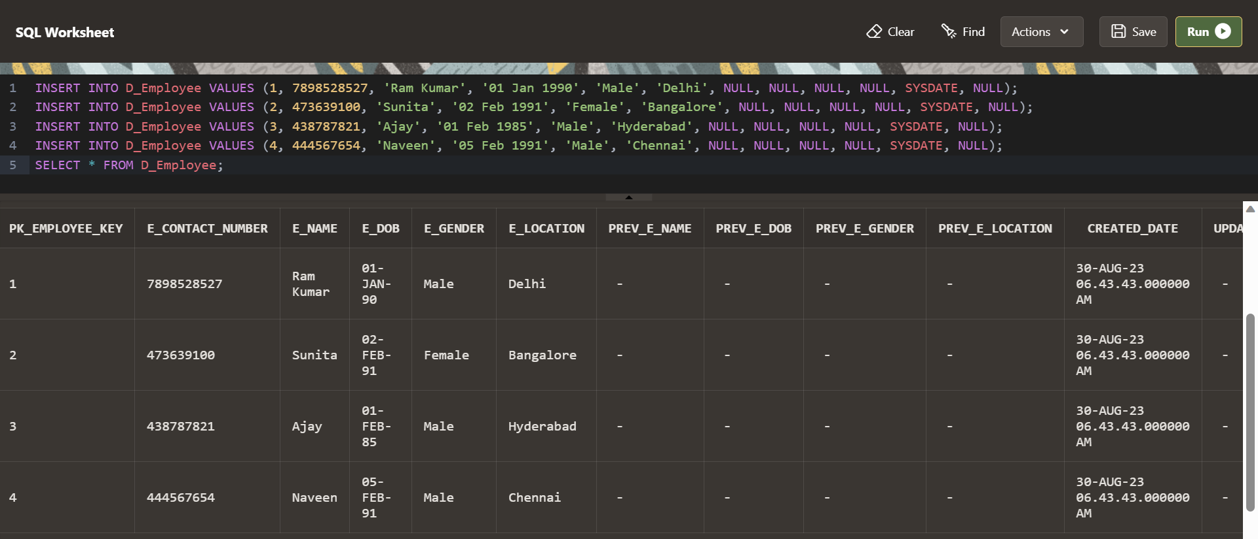

UPDATING A RECORD IN A TABLE IN TYPE-1 TABLE
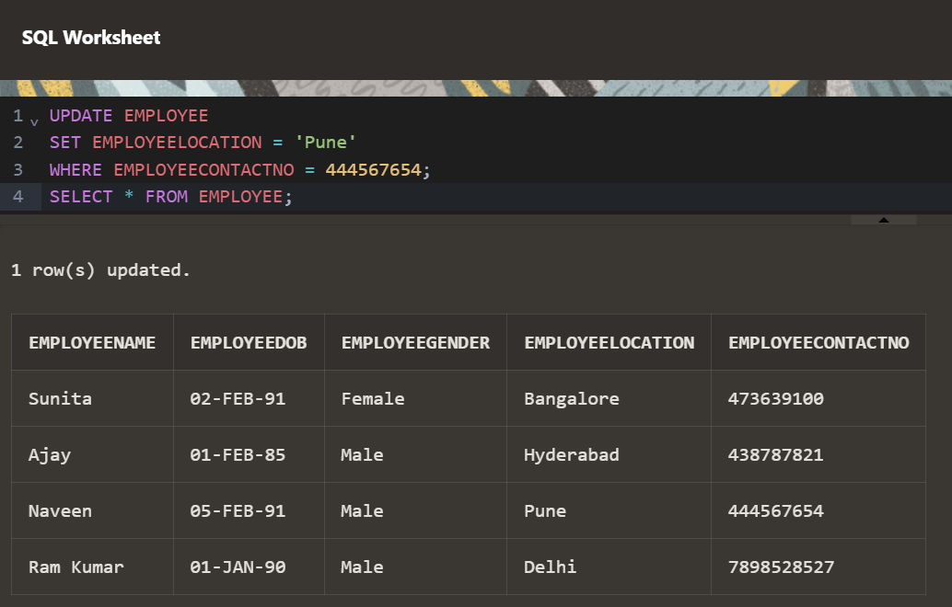

UPDATING A RECORD IN A TABLE IN TYPE-2 TABLE
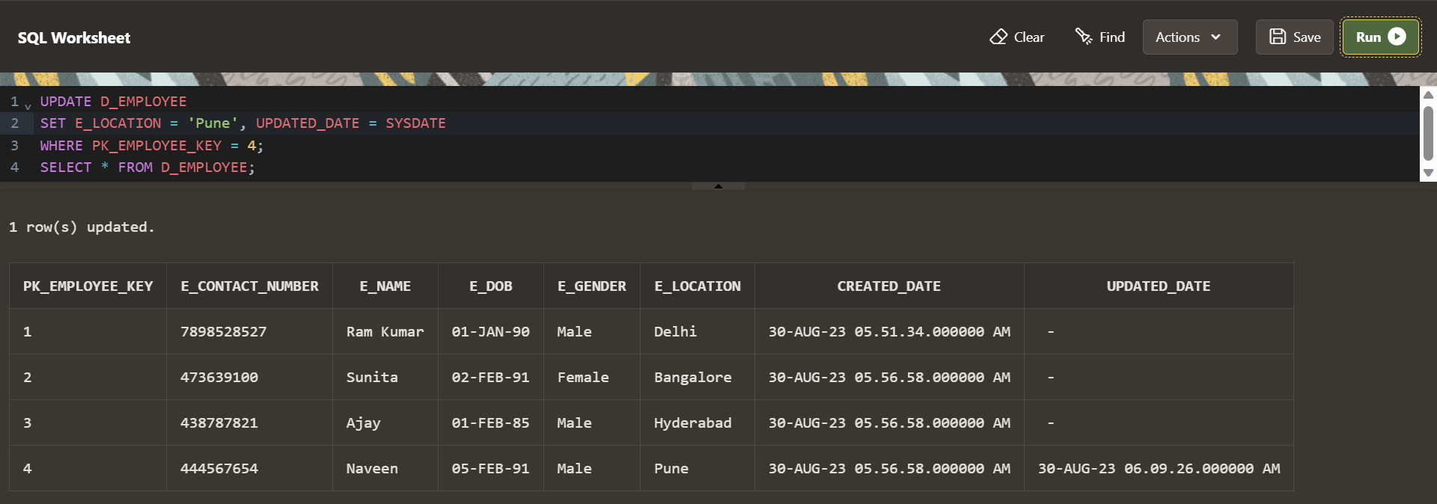

UPDATING A RECORD IN A TABLE IN TYPE-3 TABLE
